Game Design Document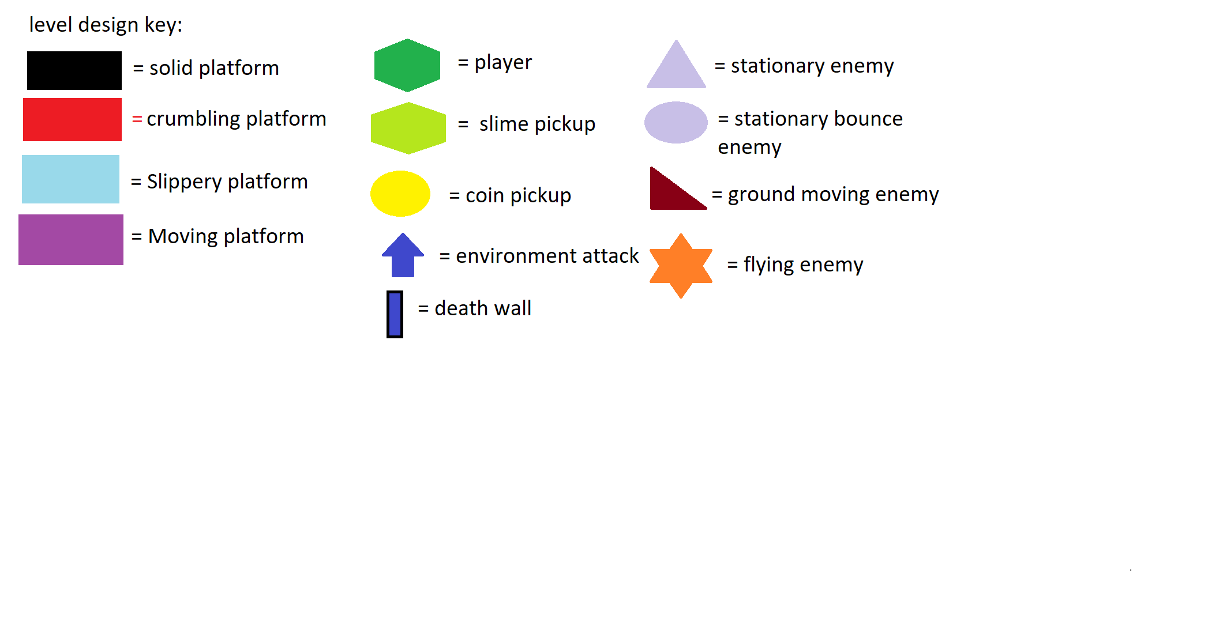

[Jelblob The Horrific Adventure]

**1.High Concept**

**1.1. Core Concept:** “Jelblob The Horrific Adventure” is an unforgiving 2D side scrolling Platformer with a unique shooting feature that punishes the player for using it.

Jelblob is the main character of the game and is a simple generic slime creature only made special by the current predicament that he finds himself in. like all slime he can move to his left, to his right and he can jump, he can also should he chose take parts of himself and fling them at his enemies but this will have a price attached. The Horrific Adventure tells the story of the time Jelblob was accidently abducted and taken aboard the evil exotic animal dealer Dr. Magmim’s Bio ship. Upon realizing he had picked up the slime the Dr. begins his ruthless purge system that will lead to the death of Jelblob even at the cost of many of the doctor’s robotic minions and his exotic collection of animals. What follows in an epically difficult race for survival as Jelblob flees the purge system through many different Bio Domes in order to reach the ships core and escape back home.

Based off similar 2D platformers The Horrific Adventure will take the player through 7 unique levels based on different world environments each level will have its own thematic version of the purge system taking the shape of a disaster found naturally in each bio dome. as well as the purge system the player will encounter a multitude of different enemies and natural environmental hazards.

The Horrific Adventure being a 2D platformer it would worth mentioning that the game has 4 different platform types some of which will affect the players movement in major ways.

This game will be made in Unity using a C# programming language and is intended for play on PC only. The game is intended to have a high difficulty level with no checkpoints or rewards for the player until the final level is completed.

**2.Gameplay Overview**

**2.1. Level structure:**

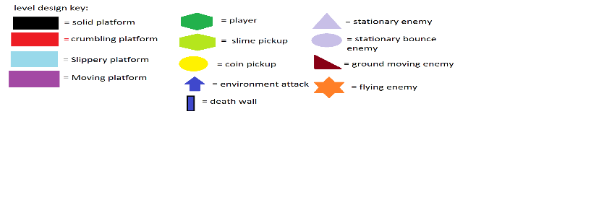

**Level 1**

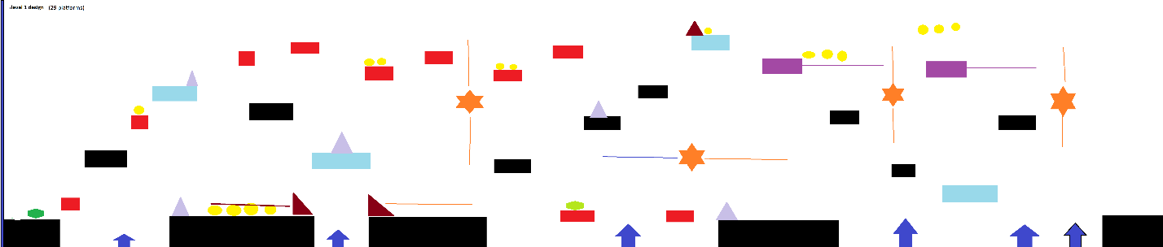

**Level 2**

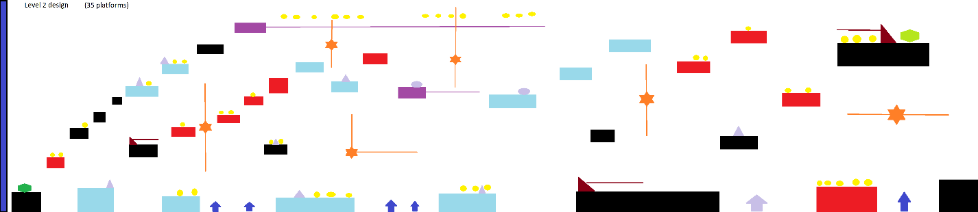

**2.2. Player controls:**

**2.3. Player interactions with platform types:**

**2.4. Player shooting and Mass mechanic:**

**2.5. Purge System and environmental attacks:**

**2.6. Coin and slime pickups:**

**2.7. Story overview:**

**3.Enemy Overview**

**3.1. Enemy Bios:**

**3.2. Enemy Functions:**

**4.The Visuals of the Horrific Adventure**

**4.1. Slimeblob visual:**

**4.2. Enemy Visuals:**

**4.3. System purge and Environmental Visuals:**

**4.4. Platform Visuals:**

**Game Title:** Jelblob’s Horrific Adventure

**Game Genre:** 2D Platformer, Scroller

**Target Audience:** 2D Platformer Fans, Scroller Fans, Quick Gamers

**Platform:** PC (Windows)

**System Requirements: ●** OS - Windows 7/8/10

**●** Processor - Core 2 Duo

**●** Graphics - DirectX 9.0c compliant video card 256MB

**Story:**

Deep within the depths of space, within a bizarre cloud of matter where many dimensions meet, an uncharted planet covered in lush jungles and open field’s lies. Deep within one of the jungles of this planet, rests a creature known as ‘Jelblob’, a slime-jelly like monster which spends its days jumping around and fleeing from predators.

One day it was resting like usual amongst a herd of animals when suddenly a giant spaceship appeared out of nowhere in the sky; and fired an abduction beam which pulled in all the animals, and Jelblob too! There was a bright light, and then suddenly Jelblob found himself within another, new jungle; however this one was within a giant glass dome surrounded by machinery. Little did he know that he had been abducted by Dr Magmin, an infamous evil genius who made his fortune by capturing and selling exotic creatures from planets across the universe.

While it might’ve not been bad for Jelblob which considered itself a lazy creature, Dr Magmin however viewed the creature as an unwanted, disgusting virus which risks contaminating his bio-dome and his collection of creatures. So he planned to release a special gas which would chase after and only disintegrate the slime creature and leave the rest of his collection unharmed, the plan was foolproof!... except he had a bad habit of leaving doors open everywhere (with the domes being no exception), and Jelblob had a talent of being able to escape anywhere.

So, take control of the Jelblob, and help him escape the bio-domes (and ultimately the spaceship) of Dr Magmin as he attempts to gas, flood, burn, bury, freeze, shred, bury again and blast away Jelblob.

**Game Walkthrough:**

As with other 2D side scrolling platformers “Jelblob’s Horrific Adventure” has the basic controls players have come to expect, the player can move left, right and jump as well as shoot in the direction they are facing.

The player will encounter multiple platform types that will have varied effects on the players movement, some will crumble to the players touch causing the player to plummet to their death if their reaction times are not quick enough, while others will slide the player across them straight into enemies or off the edge.

Jelblob will also face multiple enemy types that vary in their movement and abilities, one enemy is entirely stationary and is purely a barrier for the player while another will fly along set routes in the level and reign death upon Jelblob whenever the opportunity presents itself.

Jelblob doesn’t only have Magmim’s minions to worry about as the environment is also against him, because of the ongoing purge each level will have a thematically appropriate wall of death that will progress towards the player forcing them to move quickly or die. As well as the death walls the environment its self will also try to kill Jelblob again with thematically appropriate attacks that will strike from the ground or from above.

Jelblob’s Horrific Adventure is a very unforgiving game, there are no checkpoints there are no lives once you die it is game over and you must restart from the beginning of the game there is no easy way to win.

[Bio for core game enemy below]

* **Navigator (stationary enemy)**: These simple creations lead the charge against the player with dangerously pointy spikes on their side!... However due to Dr Magmin using cheap materials for their development, their top heads are rather fragile to anything and with their gyroscopes out of whack, they are completely unable to move despite their appearance.
* **Navigator with Bounce Helm (Stationary bounce enemy)**: Due to the amount of complaints from the Navigators department about the failure rate of Navigator missions, a new solution to the problem was to give every Navigator a bounce helm to stop their fragile heads from being cracked open, no changes have made to the gyroscopes though meaning they are still unable to move (Of course, it doesn’t solve the problem of them being so useless.)
* **\\Stickler:** Traps they are, as well as robots too (and nuisances), introducing the Stickler, a robot capable of sticking onto any surface and not moving for long periods of time (in fact, not moving at all forever); whenever an enemy walks into its reach, it will admit a healthy controlled shock which will subdue in no time! However due to their battery life, they are known to enter sleep mode for random periods of time, activating their shock functions upon wakening before going back into sleep mode…
* **\\Stickler gone Haywire:** “…okay, it has been noted recently that Sticklers tend to be in sleep mode more often than being active, so we attempted to increase their battery life and adjust some wiring so that they are able to stay awake forever. However, we can’t get close to turn off their functions and it seems at random intervals their shock function intensifies beyond the norm, so the safety distance for being near a Stickler has increased. So, all employee’s/workers are to just leave them alone and keep a safe distance always. Thank you.” – *Announcement from Dr Magmin.*
* **Enforcer:** Every leader needs his soldiers, and the Enforcer fits this bill nicely enough. A slow moving robotic tank that hovers, they lock-on to their target and mercilessly hunt it down to crush it. This puts a lot of strain on the Enforcers body, causing them to explode to the slightest force that may collide with their body… hey, at least they are smart enough to turn away from ledges.
* **Patroller (Flying enemy):** They are the eyes in the skies and enough fuel to make it past the moon, the patroller joins the chase! Built with latest (but cheapest) materials, they glide through the air, hoping to by chance to bump into their targets with their rockets; letting them feel the burn of their air superiority!
* **//Sky Patroller:** Not enough data from the prototype patrollers could be extracted before they fell victim to their fragile bodies, so for the next version of Patrollers we equipped them with the very same bounce helms used for Navigators and improved their flight capabilities; so now their survivability has greatly increased in any environment! (still not suited for actual combat, but we’ll see about that in the final version of this series…)
* **//Heavy Mag Patroller:** The true kings of the airfield and terror from above, the final version of the Patroller series comes equipped with the best air artillery at Dr Magmins disposal; proving to be an enemy none would want to come up against. Their AI has greatly improved so their smart enough to keep their height advantage, and their weapon has great spread across the field making this one enemy to always watch out for.
* **//Cold Enforcer:** With much more time spent of their development and covering their flaws, the Cold Enforcer is the ideal soldier for Dr Magmin; Bounce Helm to protect them from projectiles above them, improved hover tech to allow them to keep their height when moving across ledges into the air, and of course their new stronger weapon at their disposal. This weapons projectiles, while losing the ability from previous models projectiles of going through walls, is a strong single projectile that if it collides with any surface, it will split into 3 smaller projectiles, which 2 of them move along the hit surface going opposite directions from each other, and the 3rd moving away from the surface in a straight line.
* **//Final Enforcer:** Out of all his current creations he’s created thus far, Dr Magmin considers the Final Enforcer to be his crowning jewel; a robot that has no need for rockets or hover tech to fly, possesses a miniature energy reactor that causes no strain of the robot at all, and harnesses powerful energy into weaponized forms. The final Enforcer, due to being able to achieve a perfect balance between the intense energy with it and itself, appears to all with a zen-like appearance; being able to leave afterimages of itself as it moves from place to place, and using 2 different forms of attack. The first attack is can use is a giant laser beam, which is fires down to those below it, and the second attack fires 3 energy pellets which ricochet off any surface; it is clear to all who go up against a Final Enforcer that it will be a challenging fight.

[End of Enemy Bios]

**Analysis:**

**Hardware Required:**

|  |
| --- |
| [PC Windows] |

**Software Required:**

|  |
| --- |
| Unity [The Engine for creating the game]  Visual Studio 2016/17 [For coding the Game with C#]  Microsoft Word [For creating Documentation]  Aseprite [For images/graphics]  Audacity [For recorded audio] |

**Peripherals Required:**

|  |
| --- |
| Keyboard |

**Mood Board:**

**References:**

**Future Features:**